**Practical-3**

**AIM:** AllocatingIP address to network topologies

Student should be able to apply IP addresses to

1. Topology: two directly connected computers
2. Topology: four computers connected by switches
3. Topology: two networks connected by Router

Various networking commands:

* ping
* ipconfig
* arp –a
* netstat
* netbios
* tracert
* hostname
* nmap

Reference Videos

1. Refer Video(25 minutes) of practical-4
2. IP address: <https://www.youtube.com/watch?v=ykz4oUPWACw>
3. IP address assignment in Video: <https://www.youtube.com/watch?v=vcAtxgDsl00>

Reference for commands:

1. <https://lizardsystems.com/articles/network-command-line-utilities/>
2. <https://www.youtube.com/watch?v=nH85pddWWAk>
3. <https://www.youtube.com/watch?v=rurs7cdT5cc&t=7s>

**Note:** While applying IP address, student needs to allocate IP address as per his/her student ID. For Example, if student ID is 20ce005 then IP address allocation for the first network should start with 5.0.0.0. For subsequent networks, it should start with ID+1 i.e. 6.0.0.0, 7.0.0.0 and so on.

**Submission**: After writing an answer into this word document, Student needs to change name to his ID followed by practical number. Ex 20ce005_Pr1.docx. Upload on assignment segment.

**Rubrics**: Nicely drafted document with clarity in answers leads to full marks. Otherwise, submission carries proportional marks.

**Recommended** to type, avoid copy-paste to increase your typing skill.

----------------------------------------------------------------------------------------------------------------

**Refer to the following scenarios and let’s understand What is an IP Address and Purpose of IP Address.**

**Scenario : 1**

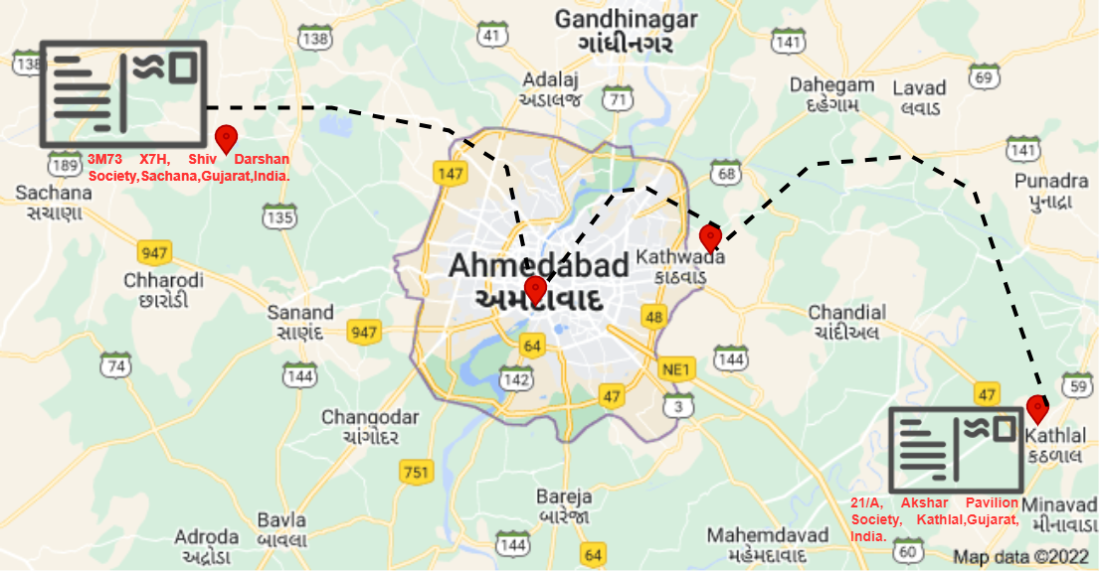

In this first scenario, an envelope is sent from sachana to kathlal. But there was some check point like ahmedabad, kathwada and then the envelope is delivered to kathlal.

Justify the following statement.

1. Was there any difficulty faced during sending the envelope from sender to receiver ?

**Scenario : 2**

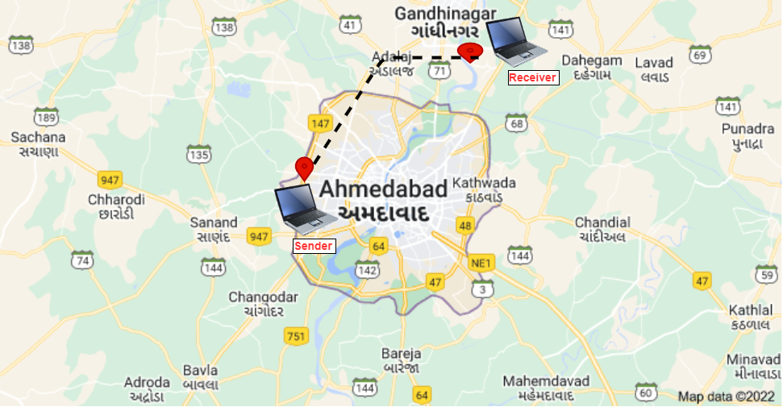

In this second scenario, the sender was located at Ahmedabad and wanted to send a file to the receiver who was located at Gandhinagar. But at the time of sending a file to the receiver, the receiver's machine was powered off. So, can the receiver receive the file from the sender or not?

Justify the following statement.

1. Was there any difficulty faced during sending the file from sender to receiver? If yes then what would be the solution for it.

**Scenario: 3**

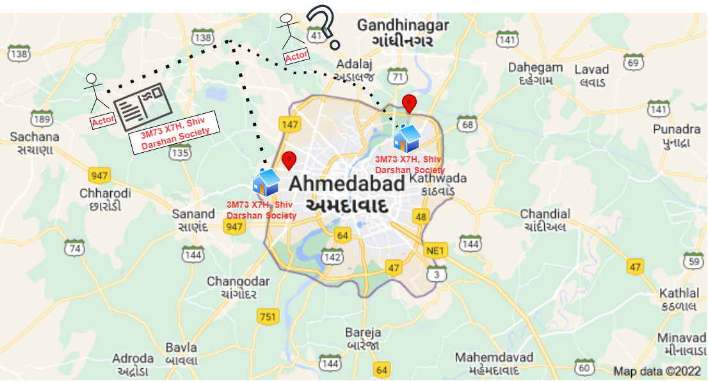

Refer the above image, and justify your answer

Question:

Can the envelope be sent to the proper destination?

**Scenario: 4**

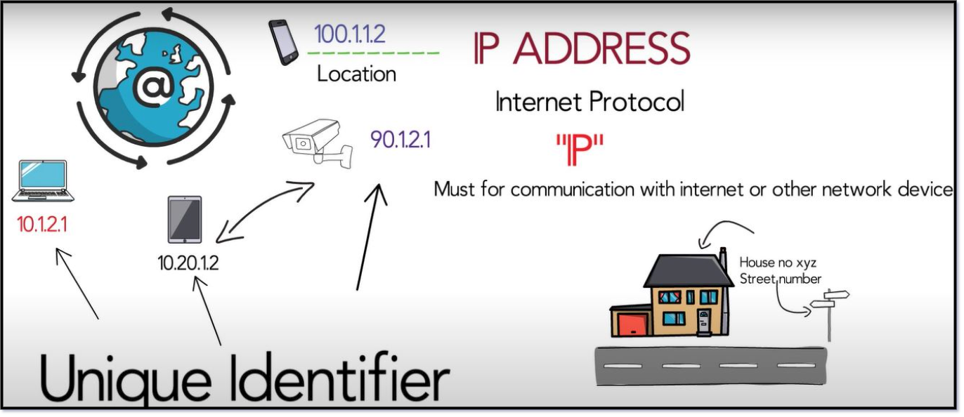

An IP address also acts like a return address on postal mail. When a letter you've mailed is delivered to the wrong address, you get the letter back if you include a return address on the envelope. The same holds true for email. When you write to an invalid recipient (such as someone who left their job and no longer has a company email address) your IP address lets the company’s mail server send you back a bounce message so that you know your email wasn't sent to the right place.

**From the above all scenarios, what would be the conclusion?**

**IP Address Types**

Basically, there are two primary types of ip address formats used today.

**1. IPv4**

**2. IPv6**

**Refer to the following diagrams and let’s understand IPv4 Address Representation**

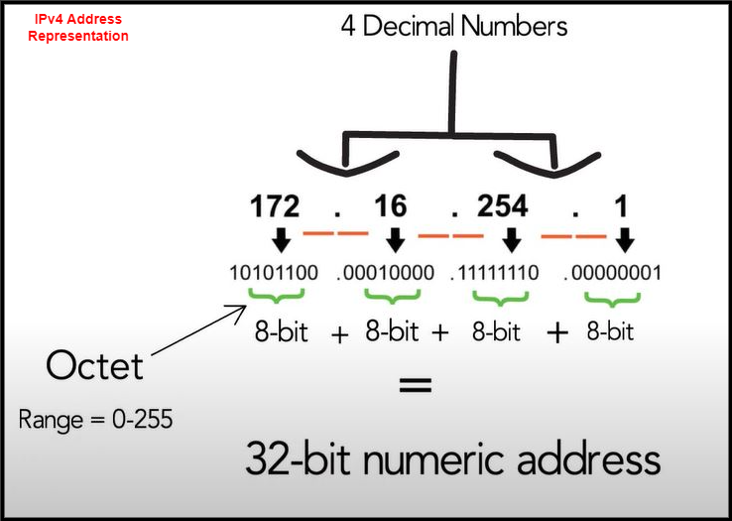

**Refer to the following case-study and let’s understand IPv4 Address Structure.**

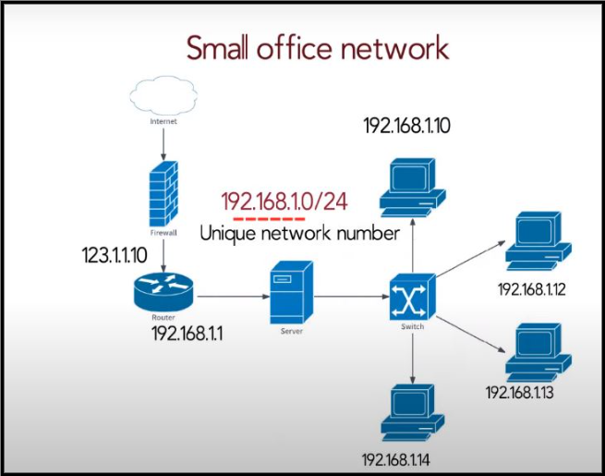

In this scenario, representing a small office network, each network running on TCP must have a unique number, and every machine on it must have a unique IP address.

An IPv4 address is a 32-bit hierarchical address that is made up of a network portion and a host portion.

When determining the network portion versus the host portion, you must look at the 32-bit stream.

A subnet mask is used to determine the network and host portions.

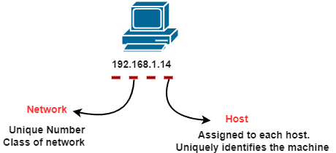

**IPv4 Address Structure**

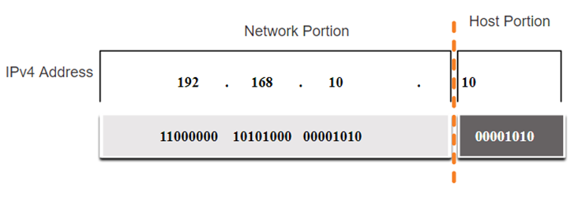

**IPv4 Address Structure using Binary format**

**IPv4 Address Structure : Subnet Mask**

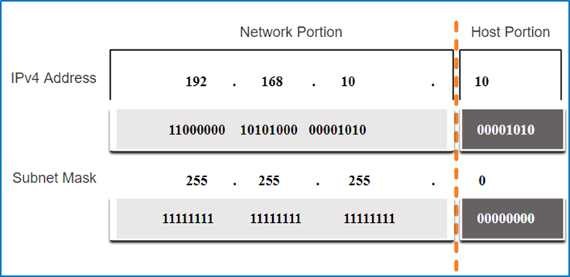

To identify the network and host portions of an IPv4 address, the subnet mask is compared to the IPv4 address bit by bit, from left to right.

The actual process used to identify the network and host portions is called ANDing.

**IPv4 Address Structure: Prefix Length**

A prefix length is a less cumbersome method used to identify a subnet mask address.

The prefix length is the number of bits set to 1 in the subnet mask.

It is written in “slash notation” therefore, count the number of bits in the subnet mask and prepend it with a slash.

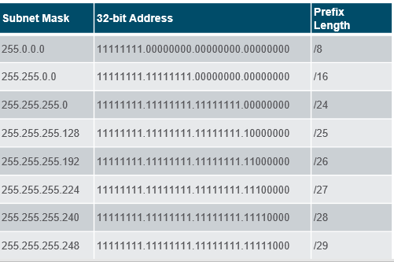

**Types of IPv4 Addresses: Legacy Classful Addressing**

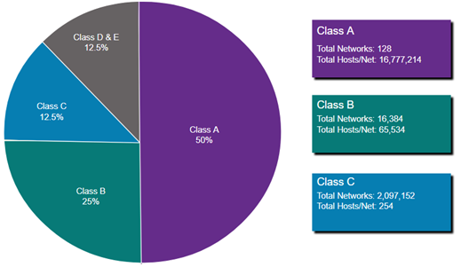

Classful addressing wasted many IPv4 addresses.

Classful address allocation was replaced with classless addressing which ignores the rules of classes (A, B, C).

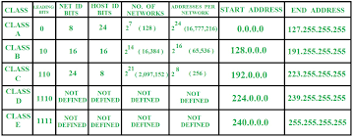

**Exercise-1**(Note: Start allocation IP address number from PC0)

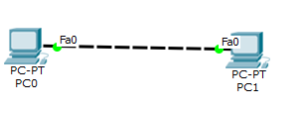

Redraw above diagram which includes IP address and MAC address. Take IP address and MAC address as per your knowledge. Insert image below.

<<Image from student>>

* Ipconfig: fill table ipconfig of all computers

PC0

|  |  |
| --- | --- |
| **Parameter** | **Value** |
| Link local IPV6 Address |  |
| IP address |  |
| Subnet Mask |  |
| Default Gateway |  |
|  |  |

PC1

|  |  |
| --- | --- |
| **Parameter** | **Value** |
| Link local IPV6 Address |  |
| IP address |  |
| Subnet Mask |  |
| Default Gateway |  |
|  |  |

* Ipconfig /all: apply command on command prompt and write parameters and values in the following table.

PC0

|  |  |
| --- | --- |
| **Parameter** | **Value** |
|  |  |
|  |  |
|  |  |
|  |  |
|  |  |

PC1

|  |  |
| --- | --- |
| **Parameter** | **Value** |
|  |  |
|  |  |
|  |  |
|  |  |
|  |  |

* Arp –a: before ping, write output of command from PC0 and PC1 computers

PC0

|  |  |
| --- | --- |
| **Parameter** | **Value** |
|  |  |
|  |  |
|  |  |
|  |  |
|  |  |

PC1

|  |  |
| --- | --- |
| **Parameter** | **Value** |
|  |  |
|  |  |
|  |  |
|  |  |
|  |  |

* Ping from PC0 to PC1 and vice versa and insert snap of output here.
* Arp –a: after ping, insert snap (below) of output of command from all computers
* Netstat: insert snap of output of command from all computers

------------------------------------------------------------------------------------------------------------

**Exercise-2:** (Note: Start allocation IP address number from PC0)

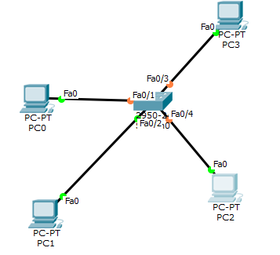

Redraw above diagram which includes IP address and MAC address. Take IP address and MAC address as per your instruction. Insert image below.

<<Image from student>>

* Ipconfig: fill table ipconfig of all computers

PC0

|  |  |
| --- | --- |
| Link local IPV6 Address |  |
| IP address |  |
| Subnet Mask |  |
| Default Gateway |  |

Similarly Prepare for PC1, PC2 and PC3

* Ipconfig /all: apply command on command prompt and write parameters and values in following table.

PC0

|  |  |
| --- | --- |
| **Parameter** | **Value** |
|  |  |
|  |  |
|  |  |
|  |  |
|  |  |

PC1

|  |  |
| --- | --- |
| **Parameter** | **Value** |
|  |  |
|  |  |
|  |  |
|  |  |
|  |  |

PC2

|  |  |
| --- | --- |
| **Parameter** | **Value** |
|  |  |
|  |  |
|  |  |
|  |  |
|  |  |

PC3

|  |  |
| --- | --- |
| **Parameter** | **Value** |
|  |  |
|  |  |
|  |  |
|  |  |
|  |  |

* Arp –a: before ping write/snap of output of command from all computers

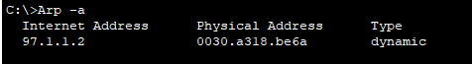

* Ping from PC0 to PC1 and vice versa and get the output here.

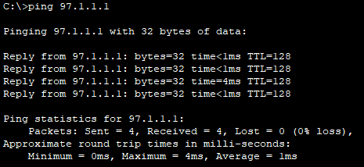

* Arp –a: after ping write/snap of output of command from all computers

PC0

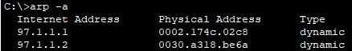

PC1

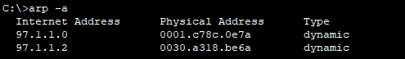

PC2

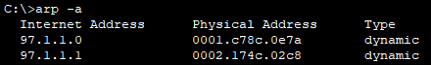

PC3



* Netstat: write/snap of output of command from all computers

PC0

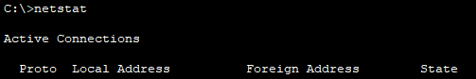

PC1

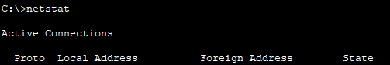

PC2

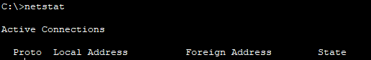

PC3



* show ip route: write/snap of output of command from all computers



Same output for all computer

----------------------------------------------------------------------------------------------------------------

**Exercise-3** (Note: Start allocation IP address number from PC0)

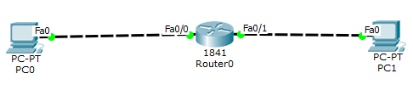

Redraw above diagram which includes IP address and MAC address. Take IP address and MAC address as per your instruction. Insert image below.

<<Image from student>>

* Ipconfig: fill following table with output of ipconfig of computer.

PC0

|  |  |
| --- | --- |
| Link local IPV6 Address |  |
| IP address |  |
| Subnet Mask |  |
| Default Gateway |  |

PC1

|  |  |
| --- | --- |
| **Parameter** | **Value** |
|  |  |
|  |  |
|  |  |
|  |  |
|  |  |

* Ipconfig /all: apply command on command prompt and write parameters and values in following table

PC0

|  |  |
| --- | --- |
| **Parameter** | **Value** |
|  |  |
|  |  |
|  |  |

PC1

|  |  |
| --- | --- |
| **Parameter** | **Value** |
|  |  |
|  |  |
|  |  |
|  |  |
|  |  |

* Arp –a: before ping write/snap of output of command from all computers

PC0



PC1



* Ping from PC0 to PC1 and vice versa and get the output here.

PC0 – PC1

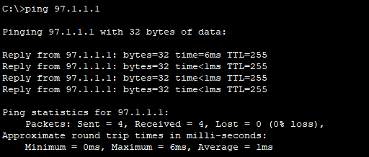

PC1 – PC0

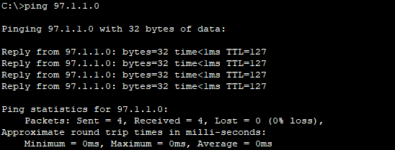

* Arp –a: after ping write/snap of output of command from all computers

PC0



PC1



* Netstat: write/snap of output of command from all computers

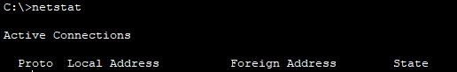

Same for all computers

* show ip route: write/snap of output of command from all computers



Same for all computers

----------------------------------------------------------------------------------------------------------------

Write answers to the following questions.

1. What are the conclusions of the ipconfig command?
2. What are the conclusions of **ipconfig /all** commands?
3. What are the conclusions of **arp -a** command before ping?
4. What are the conclusions of **netstat** -r command after ping?
5. What is my MAC address?
6. Which network is configured? Static and Dynamic
7. What is my gateway?
8. What is a hostname?
9. What is my IPv6 address?
10. What is ARPA?
11. What is a loopback address?
12. What does Port 80 mean?
13. What is the difference between logical address and physical address?
14. What is NetBIOS?

**Gate Questions :**

1. **Traceroute reports a possible route that is taken by packets moving from some host A to some other host B. Which of the following options represents the technique used by traceroute to identify these hosts:**
2. By progressively querying routers about the next router on the path to B using ICMP packets, starting with the first router
3. By requiring each router to append the address to the ICMP packet as it is forwarded to B. The list of all routers en-route to B is returned by B in an ICMP reply packet
4. By ensuring that an ICMP reply packet is returned to A by each router en-route to B, in the ascending order of their hop distance from A
5. By locally computing the shortest path from A to B
6. **Which of the following assertions is FALSE about the Internet Protocol (IP)?**
7. It is possible for a computer to have multiple IP addresses
8. IP packets from the same source to the same destination can take different routes in the network
9. IP ensures that a packet is discarded if it is unable to reach its destination within a given number of hops
10. The packet source cannot set the route of an outgoing packets; the route is determined only by the routing tables in the routers on the way
11. **Consider three IP networks A, B and C. Host HA in network A sends messages each containing 180 bytes of application data to a host HC in network C. The TCP layer prefixes 20 byte header to the message.**

**This passes through an intermediate network B.The maximum packet size, including 20 byte IP header, in each network is:**

**A: 1000 bytes**

**B: 100 bytes**

**C: 1000 bytes**

**The network A and B are connected through a 1 Mbps link, while B and C are connected by a 512 Kbps link (bps = bits per second).**

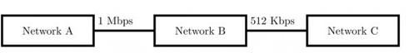

**Assuming that the packets are correctly delivered, how many bytes, including headers, are delivered to the IP layer at the destination for one application message, in the best case? Consider only data packets.**

1. 200
2. 220
3. 240
4. 260
5. **Consider three IP networks A, B and C. Host HA in network A sends messages each containing 180 bytes of application data to a host HC in network C. The TCP layer prefixes 20 byte header to the message. This passes through an intermediate network B. The maximum packet size, including 20 byte IP header, in each network, is:**

**A : 1000 bytes**

**B : 100 bytes**

**C : 1000 bytes**

**The network A and B are connected through a 1 Mbps link, while B and C are connected by a 512 Kbps link (bps = bits per second).**

* 1. 

**What is the rate at which application data is transferred to host HC? Ignore errors, acknowledgments, and other overheads.**

1. 325.5 Kbps
2. 354.5 Kbps
3. 409.6 Kbps
4. 512.0 Kbps
5. **In the IPv4 addressing format, the number of networks allowed under Class C addresses is:**
6. 214
7. 227
8. 221
9. 224

**Correct options. need to be changed.**

1. **In an IPv4 datagram, the M bit is 0, the value of HLEN is 10, the value of total length is 400 and the fragment offset value is 300. The position of the datagram, the sequence numbers of the first and the last bytes of the payload, respectively are:**
2. Last fragment, 2400 and 2789
3. First fragment, 2400 and 2759
4. Last fragment, 2400 and 2759
5. Middle fragment, 300 and 689
6. **There are n stations in slotted LAN. Each station attempts to transmit with a probability p in each time slot. What is the probability that ONLY one station transmits in a given time slot?**
7. np(1 − p)n−1
8. (1 − p)n−1
9. p(1 − p)n−1
10. 1 − (1 − p)n−1
11. **The subnet mask for a particular network is 255.255.31.0. Which of the following pairs of IP addresses could belong to this network?**
12. 172.57.88.62 and 172.56.87.23
13. 10.35.28.2 and 10.35.29.4
14. 191.203.31.87 and 191.234.31.88
15. 128.8.129.43 and 128.8.161.55
16. **The routing table of a router is shown below:**

|  |  |  |
| --- | --- | --- |
| **Destination** | **Subnet Mask** | **Interface** |
| **128.75.43.0** | **255.255.255.0** | **Eth0** |
| **128.75.43.0** | **255.255.255.128** | **Eth1** |
| **192.12.17.5** | **255.255.255.255** | **Eth3** |
| **Default** |  | **Eth2** |

**On which interface will the router forward packets addressed to destinations 128.75.43.16 and 192.12.17.10 respectively?**

1. Eth1 and Eth2
2. Eth0 and Eth2
3. Eth0 and Eth3
4. Eth1 and Eth3
5. **An organization has a class B network and wishes to form subnets for 64 departments. The subnet mask would be:**
6. 255.255.0.0
7. 255.255.64.0
8. 255.255.128.0
9. 255.255.252.0
10. **Two computers C1 and C2 are configured as follows. C1 has IP address 203.197.2.53 and netmask 255.255.128.0 .C2 has IP address 203.197.75.201 and netmask 255.255.192.0 . Which one of the following statements is true?**
11. C1 and C2 both assume they are on the same network
12. C2 assumes C1 is on same network, but C1 assumes C2 is on a different network
13. C1 assumes C2 is on same network, but C2 assumes C1 is on a different network
14. C1 and C2 both assume they are on different networks.
15. **The address of a class B host is to be split into subnets with a 6-bit subnet number. What is the maximum number of subnets and the maximum number of hosts in each subnet?**
16. 62 subnets and 262142 hosts.
17. 64 subnets and 262142 hosts.
18. 62 subnets and 1022 hosts.
19. 64 subnets and 1024 hosts.
20. **If a class B network on the Internet has a subnet mask of 255.255.248.0 , what is the maximum number of hosts per subnet?**
21. 1022
22. 1023
23. 2046
24. 2047
25. **Suppose computers A and B have IP addresses 10.105.1.113 and 10.105.1.91 respectively and they both use same netmask N. Which of the values of N given below should not be used if A and B should belong to the same network?**
26. 255.255.255.0
27. 255.255.255.128
28. 255.255.255.192
29. 255.255.255.224
30. **An Internet Service Provider (ISP) has the following chunk of CIDR-based IP addresses available with it: 245.248.128.0/20 . The ISP wants to give half of this chunk of addresses to Organization A, and a quarter to Organization B, while retaining the remaining with itself. Which of the following is a valid allocation of addresses to A and B?**
31. 245.248.136.0/21 and 245.248.128.0/22
32. 245.248.128.0/21 and 245.248.128.0/22
33. 245.248.132.0/22 and 245.248.132.0/21
34. 245.248.136.0/24 and 245.248.132.0/21
35. **Consider the following routing table at an IP router:**

|  |  |  |
| --- | --- | --- |
| **Network No** | **Net Mask** | **Next Hop** |
| **128.96.170.0** | **255.255.254.0** | **Interface 0** |
| **128.96.168.0** | **255.255.254.0** | **Interface 1** |
| **128.96.166.0** | **255.255.254.0** | **R2** |
| **128.96.164.0** | **255.255.252.0** | **R3** |
| **0.0.0.0** | **Default** | **R4** |

**For each IP address in Group I Identify the correct choice of the next hop from Group II using the entries from the routing table above.**

|  |  |
| --- | --- |
| **Group I** | **Group II** |
| **i) 128.96.171.92** | **a) Interface 0** |
| **ii) 128.96.167.151** | **b) Interface 1** |
| **iii) 128.96.163.151** | **c) R2** |
| **iv) 128.96.164.121** | **d) R3** |
|  | **e) R4** |

1. i-a, ii-c, iii-e, iv-d
2. i-a, ii-d, iii-b, iv-e
3. i-b, ii-c, iii-d, iv-e
4. i-b, ii-c, iii-e, iv-d
5. **In the network 200.10.11.144/27 , the fourth octet (in decimal) of the last IP address of the network which can be assigned to a host is ___________.**
6. **Consider three machines M, N, and P with IP addresses 100.10.5.2, 100.10.5.5 , and 100.10.5.6 respectively. The subnet mask is set to 255.255.255.252 for all the three machines. Which one of the following is true?**
7. M, N, and P all belong to the same subnet
8. Only M and N belong to the same subnet
9. Only N and P belong to the same subnet
10. M, N, and P belong to three different subnets
11. **An organization requires a range of IP address to assign one to each of its 1500 computers. The organization has approached an Internet Service Provider (ISP) for this task. The ISP uses CIDR and serves the requests from the available IP address space 202.61.0.0/17 . The ISP wants to assign an address space to the organization which will minimize the number of routing entries in the ISP’s router using route aggregation. Which of the following address spaces are potential candidates from which the ISP can allot any one of the organization?**
    1. **202.61.84.0/21**
    2. **202.61.104.0/21**
    3. **202.61.64.0/21**
    4. **202.61.144.0/21**
12. I and II only
13. II and III only
14. III and IV only
15. I and IV only
16. **A subnet has been assigned a subnet mask of 255.255.255.192 . What is the maximum number of hosts that can belong to this subnet?**
17. 14
18. 30
19. 62
20. 126
21. **A company has a class C network address of 204.204.204.0 . It wishes to have three subnets, one with 100 hosts and two with 50 hosts each. Which one of the following options represents a feasible set of subnet address/subnet mask pairs?**
22. 204.204.204.128/255.255.255.192

204.204.204.0/255.255.255.128

204.204.204.64/255.255.255.128

1. 204.204.204.0/255.255.255.192

204.204.204.192/255.255.255.128

204.204.204.64/255.255.255.128

1. 204.204.204.128/255.255.255.128

204.204.204.192/255.255.255.192

204.204.204.224/255.255.255.192

1. 204.204.204.128/255.255.255.128

204.204.204.64/255.255.255.192

204.204.204.0/255.255.255.192

1. **A subnetted Class B network has the following broadcast address: 144.16.95.255. Its subnet mask**
2. is necessarily 255.255.224.0
3. is necessarily 255.255.240.0
4. is necessarily 255.255.248.0
5. could be any one of 255.255.224.0 , 255.255.240.0 ,255.255.248.0

1. **Host X has IP address 192.168.1.97 and is connected through two routers R1 and R2 to another host Y with IP address 192.168.1.80.    Router R1   has   IP   addresses 192.168.1.135     and 192.168.1.110 . R2 has IP addresses 192.168.1.67 and 192.168.1.155 . The netmask used in the network is 255.255.255.224 .**
2. **Given the information above, how many distinct subnets are guaranteed to already exist in the network?**
3. 1
4. 2
5. 3
6. 6
7. **Host X has IP address 192.168.1.97 and is connected through two routers R1 and R2 to another host Y with IP address 192.168.1.80. Router R1 has IP addresses 192.168.1.135 and 192.168.1.110 . R2 has IP addresses 192.168.1.67 and 192.168.1.155 . The netmask used in the network is 255.255.255.224 .**
8. **Which IP address should X configure its gateway as?**
9. 192.168.1.67
10. 192.168.1.110
11. 192.168.1.135
12. 192.168.1.155
13. **A computer on a 10 Mbps network is regulated by a token bucket. The token bucket is filled at a rate of 2 Mbps. It is initially filled to capacity with 16 Megabits. What is the maximum duration for which the computer can transmit at the full 10 Mbps?**
14. 1.6 seconds
15. 2 seconds
16. 5 seconds
17. 8 seconds
18. **For a host machine that uses the token bucket algorithm for congestion control, the token bucket has a capacity of 1 megabyte and the maximum output rate is 20 megabytes per second. Tokens arrive at a rate to sustain output at a rate of 10 megabytes per second. The token bucket is currently full and the machine needs to send 12 megabytes of data. The minimum time required to transmit the data is ________________ seconds.**
19. **In the diagram shown below, L1 is an Ethernet LAN and L2 is a Token-Ring LAN. An IP packet originates from sender S and traverses to R, as shown. The links within each ISP and across the two ISPs, are all point-to-point optical links. The initial value of the TTL field is 32. The maximum possible value of the TTL field when R receives the datagram is _____________.**

